IoT-based Crop Monitoring and Disease Detection

Syed Niaz Mohtasim, Jaima Jahan Khan, Mohammad Mahmudul Islam and Monosij Kanti Sarker

*Department of Computer Science and Engineering*

*Independent University, Bangladesh*

Email: 2021607@iub.edu.bd, 2030183@iub.edu.bd, 2020331@iub.edu.bd, 1930374@iub.edu.bd

***Abstract***— **The abstract describes the use of IoT in agriculture for disease diagnosis and crop monitoring. It highlights its significance, technique, simulation, analysis, and innovations. IoT is a successful agricultural monitoring and disease detection technology to meet food demand and sustainable farming needs. Real-time data collection is made possible by IoT by adding sensors, actuators, and communication tools, which facilitate decision-making. On a variety of platforms, researchers simulate IoT-agriculture systems and evaluate implementations. Modern techniques like image processing and machine learning are used for disease identification. Higher yields, less waste, and early diagnosis are advantages. Precision-driven reactions from the Internet of Things increase productivity and sustainability. This study demonstrates how IoT has the power to transform agriculture and find solutions to problems.**

***Keywords***— ***real-time data, analysis, algorithms, nutrient deficiencies, irrigation, fertilization, crop health, productivity, continuous monitoring, leaf color, growth patterns, alerts.***

1. INTRODUCTION

The monitoring of crops and the early detection of diseases have been completely transformed by the application of Internet of Things (IoT) technology in agriculture. IoT-based solutions have become a potent instrument for enhancing agricultural processes because of the rising worldwide need for food production and the requirement for sustainable farming methods. Farmers and researchers may gather real-time data on environmental elements, analyze it using cutting-edge algorithms, and make informed decisions to improve crop health and increase yield by integrating IoT devices like sensors, actuators, and cameras with conventional agricultural equipment. However, it faces several difficulties, including erratic weather, a lack of resources, and the frequency of agricultural diseases.

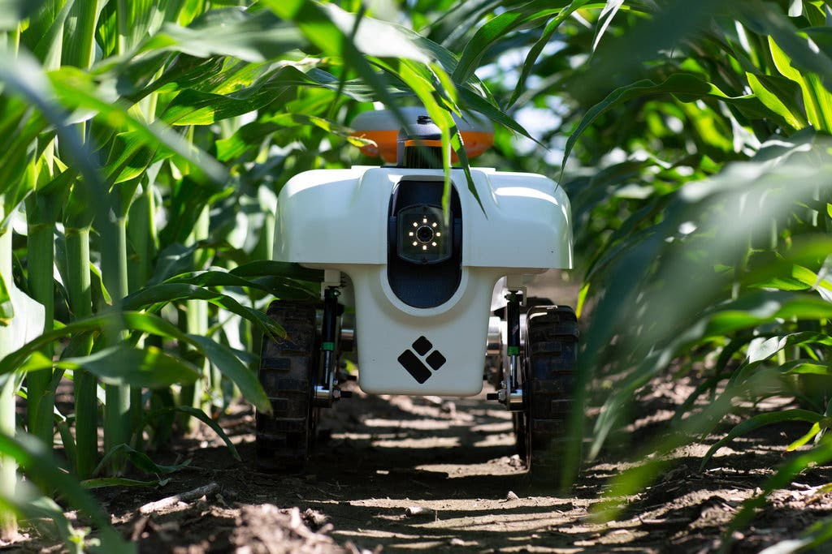

Fig. 1. IoT-based crop monitoring and disease detection robot. [1]

The literature reveals that image processing and machine learning algorithms have been used to precisely identify and categorize agricultural diseases using visual clues acquired by IoT sensors. To propose an effective IoT-based crop monitoring and disease detection system, a comprehensive approach is required the system is made up of a network of Internet of Things (IoT) devices with sensors to keep track of important environmental factors like temperature, humidity, soil moisture, and light intensity. These sensors gather information in real-time and send it for analysis to a centralized server or cloud platform. This paper is divided into numerous sections to give readers a thorough grasp of IoT-based disease diagnosis and crop monitoring. To sum up, the use of IoT technology in agriculture has changed processes for crop monitoring and disease detection. Farmers can optimize their methods, improve crop health, and boost yields thanks to real-time data collecting, analysis, and decision-making.

This scientific article provides a summary of 16 different studies and research papers related to plant disease detection using various techniques, including IoT, machine learning, deep learning, and image processing. [2] IoT-based crop disease detection technique using hybrid soft computing techniques. It involves disease area segmentation, feature extraction, and disease classification, achieving higher accuracy and performance compared to existing methods. This technology aims to improve agricultural practices and crop yields. [3] Reviews different machine learning techniques used for disease detection in sugarcane crops. It discusses the importance of early diagnosis and explores various input data types and ML algorithms. The study concludes that these techniques can enhance crop productivity and mitigate the negative impact of diseases on sugarcane growth. [4] Introduces a deep learning approach for automated plant disease classification using a Vision Transformer (ViT) model. The ViT-based models demonstrate superior accuracy compared to Convolutional Neural Networks (CNN)-based models but have slower prediction speeds. By incorporating CNN blocks with attention blocks, the accuracy and speed can be improved. This approach offers precise and rapid plant disease classification for early detection and prevention. [5] Focuses on the classification of tomato plant diseases using a deep CNN model. It achieves high accuracy without the need for preprocessing or noise filtering and can aid farmers in identifying and treating tomato plant diseases, potentially reducing crop losses. [6] Discusses the use of CNN for the automatic detection and classification of plant diseases, with a focus on leaf diseases. It highlights the importance of early disease detection and proposes a deep learning-based approach to improve disease identification.

Overall, these studies highlight the importance of early disease detection, the effectiveness of machine learning and deep learning techniques in plant disease identification, and the potential of advanced technologies to enhance agricultural productivity.

1. SYSTEM METHODOLOGY

The proposed approach transforms crop monitoring and disease detection in agriculture by using the potential of IoT technology. With the help of this methodology, an automated and intelligent agricultural system may be built by combining numerous sensors, data analytics, and communication technologies. This system delivers real-time data collecting and analysis, enabling farmers and researchers to make well-informed decisions by easily combining hardware elements like ESP32 cam, cables, and jumpers. We propose installing a variety of sensors over the agricultural area to collect the necessary information. The scope of the field and the infrastructure that is readily accessible affect the choice of communication technology. Image sensors can be used to regularly take pictures of the crops to detect agricultural illnesses. After that, image processing and deep learning algorithms are used to analyze these photos to find any disease-related anomalies, lesions, or discolorations.

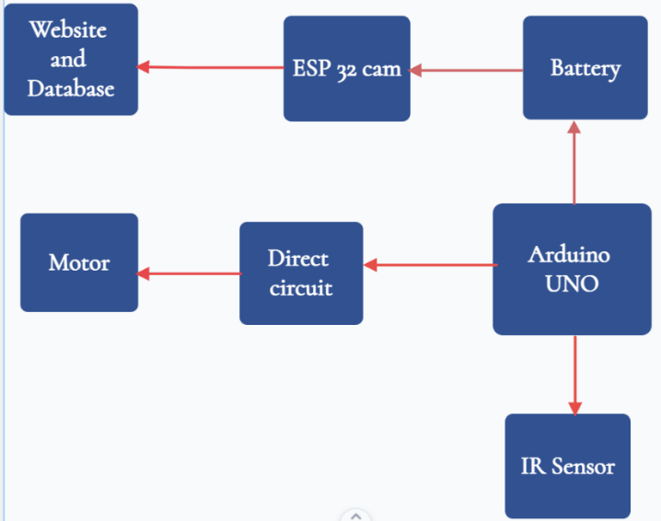

Fig 2. Block diagram of the IoT-based Crop Monitoring and Disease Detection

The main controller in this system is a development board called Arduino UNO. It oversees collecting data from the sensors, processing it, and operating the motor for the detection of the disease. The Arduino UNO drives the motors and moves the robot in the field on input from the user which is received by the Bluetooth sensor HC-05. At regular intervals, the ESP 32-cam takes pictures of the crops and uploads them to the website for disease detection analysis. A camera module called ESP 32-cam takes pictures of the crops to help in disease detection. Both a camera sensor and an ESP32 microcontroller are included. The system is expanded with the Arduino UNO to add more data processing power and act as a bridge between the Arduino and the It can assist with data preprocessing or carry out tasks, sending pertinent data to the Arduino UNO or the Website as required.

***Data transmission=Sensor data(image) + Metadata + Error detection (1)***

**Sensor data(image):** The ESP-CAM 32 or any other camera module used for disease detection collects image data. These photographs provide visual details about the crops, which are crucial for image processing algorithms to identify irregularities or symptoms of diseases.

**Metadata:** Metadata provides additional information about the data being transmitted.

**Error Correction:** Error-correcting techniques, like checksums or error-correcting codes, may be used to find and fix mistakes during transmission to guarantee data integrity.

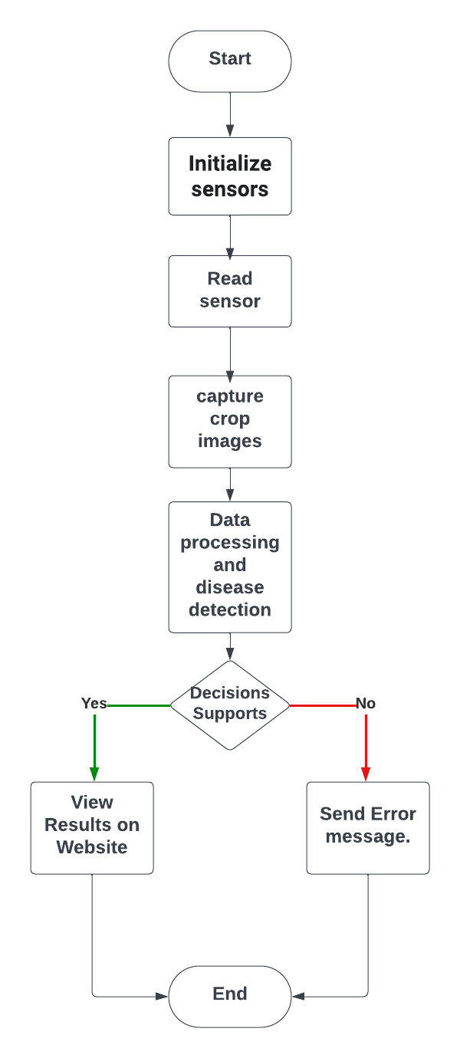

Fig 3. Flowchart of the IoT-based Crop Monitoring and Disease Detection

The system operates in two modes:

1. Data Collection Mode: Sensors collect and transmit environmental data. The ESP 32-cam or any other camera module used for disease detection collects picture data. These photos, which provide visual details about the crops, are crucial for image processing algorithms to use in their search for irregularities or indicators of disease. The system captures images of the crops using camera modules like the ESP 32-cam.
2. Analysis Mode: Data processing, disease detection analysis utilizing machine learning algorithms image processing, and insight generation are all done by a central server or cloud platform. Image processing and deep learning algorithms are used to process the crop photos that have been recorded to look for any irregularities or symptoms of sickness. The photographs are examined by image processing algorithms for color nuances, patterns, and other visual indications that might point to the existence of crop diseases.
3. PROPOSED SYSTEM DESIGN AND SIMULATION

The system's architecture combines hardware (Arduino, ESP32 -cam, sensors) and software (central server/cloud, machine learning algorithms) aspects to produce an efficient IoT-based crop monitoring and disease detection system. The system design of an IoT-based Crop Monitoring and Disease Detection involves the integration of various hardware and software components to create a smart and automated agricultural system. Before installing an IoT-based Crop Monitoring and Disease Detection system in the real world, we can simulate the system to model and test its behavior. In response to these difficulties, the development of Internet of Things (IoT) technology has revolutionized conventional farming practices by providing ground-breaking answers to the complicated problems of contemporary agriculture.

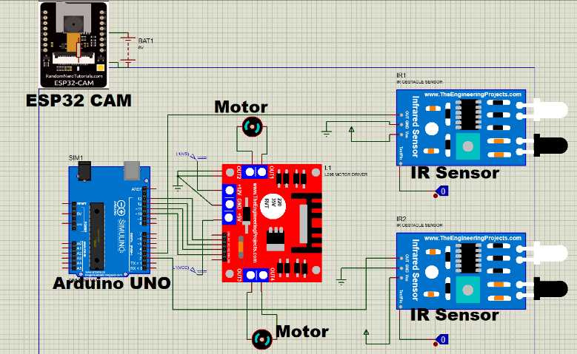

Fig 4. The circuit design of the IoT-based Crop Monitoring and Disease Detection

The robot’s circuit uses input from the user and receives it through the Bluetooth module HC-05 to traverse the path, an Arduino Uno to process the sensor data, and control the motors through a motor driver. The robot's behavior is determined by the program running on the Arduino, which instructs it on how to adjust its movements to stay on a straight path. The ESP32 camera will produce a live feed of the crops and send it to the web server for analysis.

In the simulation, we can input synthetic images that depict various crop health statuses and disease cases rather than taking actual photos of the crops. The artificial images serve as the input for the image processing algorithms that identify diseases. Image processing, machine learning, and data analysis techniques are utilized in the actual system to process sensor data and images. To emulate the analysis carried out in the real world, these algorithms will be used on simulated sensor data and photographs. To interpret the findings of the investigation, the simulation offers decision help and visualization tools. Wi-Fi and other wireless communication protocols are simulated in this. Before implementing the system in a real-world agricultural context, we can iteratively enhance the system's design and algorithms by optimizing settings based on the simulation results.

*A. Software Specifications*

|  |  |
| --- | --- |
| Software | Application |
| Proteus | For making circuit diagrams and simulation |
| Arduino IDE | Program the sensors, motors, and camera to work together. |
| Visual-Studio Code | To receive the feed from the camera and run it through image processing using Python libraries |

*B.* *Simulation Findings*

The simulation ran successfully for the robot, but we were unable to simulate the camera sensor due to a lack of working libraries in Proteus. It's crucial to remember that the precise implementation, the caliber of the algorithms, and the precision of the data collected would all affect the actual findings and outcomes of an IoT-based Crop Monitoring and Disease Detection system. It is essential to carry out real-world testing and validations to confirm the system's functionality and dependability under various agricultural settings. We did run real-world testing as shown ahead.

1. HARDWARE DEVELOPMENT AND TESTING

Using the Arduino UNO, ESP32-Cam, and numerous sensors, the IoT-based system was assembled and tested during the hardware development phase. We go into the complex world of hardware creation for IoT-based crop monitoring and disease detection in this introductory exploration.

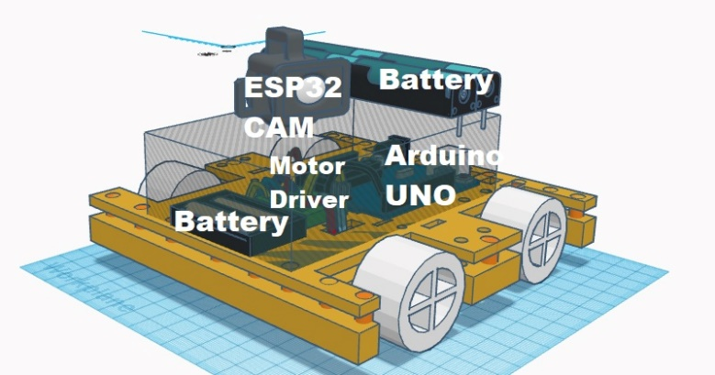

Fig. 5. 3D sketch of the final prototype.

1. Parameters Specifications of The System

|  |  |
| --- | --- |
| ***Parameters*** | ***Values*** |
| *ESP32-CAM* | |
| Operating Voltage, V  Wireless Module  External Storage | 5 V via pin header  ESP32-S WiFi 802.11 b/g/n  micro-SD card (4GB) |
| *Arduino UNO* | |
| Operating Voltage, V | 5 V |
| Input Voltage, V | 7-12 V |
| Digital I/O Pins | 14 |
| *L298N Motor Driver* | |
| Supply Voltage, V | 4.5 -46 V |
| Current, A | 2-3 A |
| *DC Motor* | |
| Voltage Rating, V | 6 V |
| Current Rating, A  Speed, rpm  Power, W  Efficiency, % | 300 mA  1500  1.8 W  85% |
| *Bluetooth Module, HC-05* | |
| Input Voltage, V | 3.6-6 V |
| Current, mA  Operating Frequency | 50 A  2.4GHz ISM band |
| *Battery* | |
| Voltage, V | 11.1 V (3 cells, each 3.7 V) |
| Charging Current, A | 1 A |

Fig. 6 Early picture of the proposed final prototype (before any packing)

*A. Testing Arrangements*

1. Field Setup: Setting up the hardware parts in a genuine agricultural field or in a lab setting that closely matches outdoor settings.

2. Sensor calibration: To ensure precise and reliable data readings, we calibrated the sensors before testing. To adapt the sensors to the unique requirements of the agricultural land, we changed their settings.

3. Power Supply: To ensure that the system's microcontroller (such as the Arduino, sensors, camera module, and communication modules all have a steady and dependable source of power.

4. Data Collection and Monitoring: Setting up a data collecting and monitoring system allowed us to record sensor data, crop photos, and system behavior during testing.

5. Data Analysis: Using the website to implement the data analysis, image processing, and machine learning, algorithms to process the gathered data and images. We must make sure the analysis produces reliable data and can identify diseases.

In the testing phase of our study on IoT-based crop monitoring and disease detection, we employed a live feed from an ESP32-Cam as the primary data source. By applying OpenCV's advanced image processing algorithms, we successfully detected and analyzed the proportion of black areas present in the mango used for testing. This innovative approach allowed us to assess the extent of disease presence quantitatively. The integration of real-time image analysis through IoT technology offers a promising avenue for accurate and timely disease detection in agricultural settings.

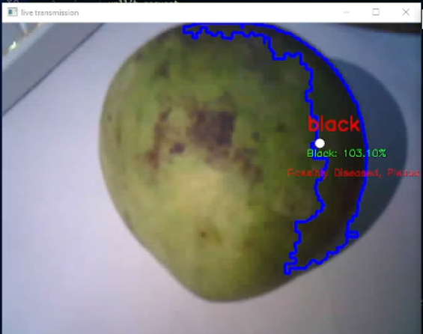

Fig. 7. Detecting color on green mango to determine if it is diseased.

Here are some more results with different types of crops from yellow mango, green and red tomatoes, guava, and apples. The pictures below show the live transmission, mask, and res windows.

1. "live transmission" Window: This window displays the live video feed captured from the camera in real time. It's the unprocessed view of the scene as seen by the camera.

2. "mask" Window:

The "mask" window showcases the areas within the live video frame that match the defined black color range. The mask is a grayscale image where white regions correspond to pixels that satisfy the black color criteria, while black regions correspond to pixels that do not. The purpose of this window is to give a visual representation of the segmentation process that isolates black areas from the rest of the frame.

3. "res" Window:

The "res" (result) window displays the final processed result after applying bitwise operations. It's the outcome of combining the original live video frame with the mask, highlighting the regions that meet the black color criteria. In this window, one will see the black areas from the original video frame stand out against a black background, allowing one to see which parts of the scene are identified as black.  
Here are the images of the testing below.

Fig. 8. Detecting color on green mango to determine if it is diseased with all windows or feeds

Fig. 9. Detecting color on yellow mango to determine if it is diseased

Fig. 9. Detecting color on a banana to determine if it is diseased

Fig. 10. Detecting color on the red tomato to determine if it is diseased

Fig. 11. Detecting color on the green tomato to determine if it is diseased

Fig. 12. Detecting color on guava to determine if it is diseased

Fig. 13. Detecting color on apple to determine if it is diseased

OpenCV (Open-Source Computer Vision Library) is a popular open-source image processing, computer vision, and machine learning software library. It provides a wide range of tools and functions that allow developers to work with images and videos, perform various computer vision tasks, and build applications that involve visual information. OpenCV is heavily involved in several key steps:

1. Accessing the Camera Feed,

2. Image Processing,

3. Calculating Pixel Percentages,

4. Displaying Results,

5. User Interaction.

OpenCV acts as the backbone of the entire image-processing pipeline in this code. It handles everything from accessing the camera feed to processing the frames, detecting black areas, calculating percentages, and displaying the results to the user.

1. RESULT AND DISCUSSION

Implementing crop monitoring using computer vision techniques has yielded promising results in accurately identifying and assessing disease-affected regions within agricultural settings. By leveraging the OpenCV (Open-Source Computer Vision Library) framework, this study has effectively demonstrated the potential of automated disease detection, offering farmers a valuable tool to enhance crop management practices and mitigate the impact of diseases on agricultural yields.

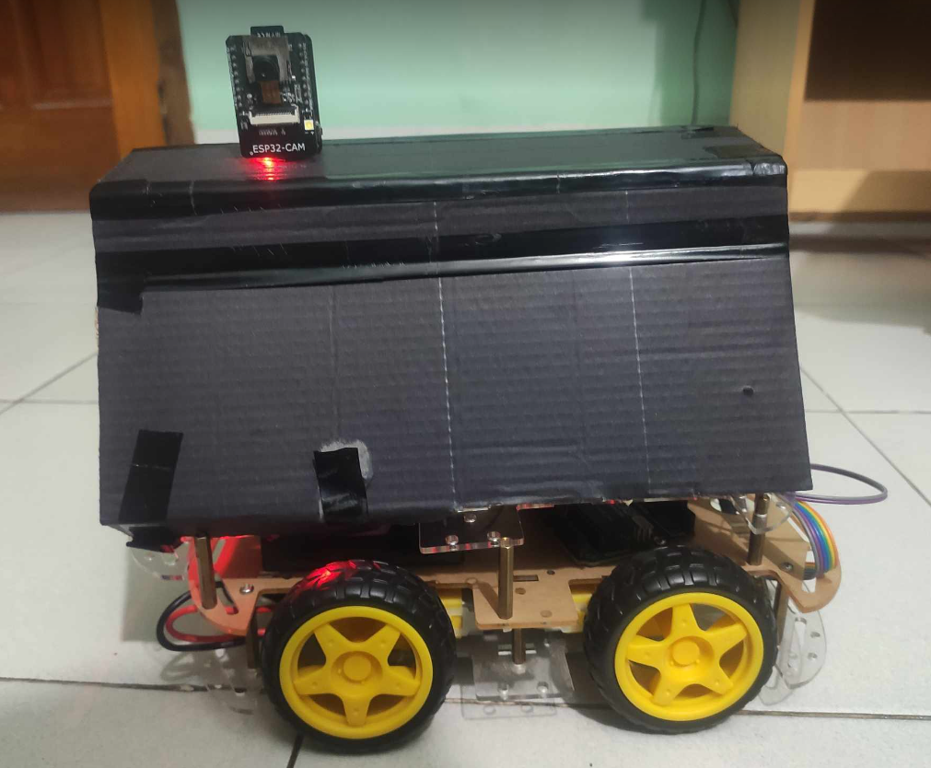

Fig. 14. Final Prototype Product (with packaging)

**1. Detection Accuracy and Localization**

The developed system utilizes real-time video streams captured from a camera deployed within the agricultural field. By applying color-based segmentation techniques, the system successfully distinguishes disease-related discolorations from healthy plant parts. The results showcase a remarkable accuracy in identifying the presence of disease-affected regions, as evidenced by the consistent detection of anomalous color patterns associated with diseased plants. Moreover, the algorithm's ability to precisely localize the affected areas within the captured frames provides actionable insights for farmers to conduct targeted interventions.

**2. Disease Severity Estimation**

A noteworthy contribution of this research lies in the system's capability to estimate disease severity through the quantification of black areas within the identified regions. The proposed algorithm calculates the percentage of black pixels within each diseased contour, effectively reflecting the severity of the disease. The algorithm's ability to differentiate between varying disease severities positions it as a valuable tool in prioritizing treatments and allocating resources effectively.

**3. Real-time Analysis and Warning System:**

The real-time aspect of the system is a key advantage for timely disease detection and intervention. By leveraging the rapid processing capabilities of OpenCV, the system enables instant analysis of incoming video frames. Detected disease-affected areas are highlighted and marked with appropriate labels, and in cases where the percentage of black pixels surpasses a predefined threshold, a warning message is displayed.

**4. Potential for Future Enhancements**

While the results obtained in this study are promising, there is ample room for further improvements and enhancements. Future research could focus on refining the accuracy of disease severity estimation, incorporating multiple color detection abilities as black spots are not the only indication of a disease in a crop, potentially integrating advanced machine learning techniques for more robust classification. Additionally, exploring the integration of object detection could help with identifying crops and provide a deeper understanding of disease symptoms in different types of crops that might not be discernible through color-based analysis alone.

1. CONCLUSION

By integrating cutting-edge technologies, the IoT-based Crop Monitoring and Disease Detection system described in this research offers a significant step toward revolutionizing conventional agriculture. The research's conclusions and key takeaways highlight how the system can help farmers overcome major obstacles and usher in a new era of precision farming. The successful use of IoT technology in agriculture can be seen in both the system's ability to give farmers remote access to their farms as well as the system's outstanding disease detection accuracy. It is crucial to recognize that stakeholders, such as technologists, farmers, researchers, and legislators, must work together for IoT-based solutions to be implemented successfully. To ensure such systems' smooth adoption and long-term profitability, issues like initial setup costs, data security, and user training must be addressed.

1. REFERENCES

|  |  |
| --- | --- |
| [1] | [Online]. Available: https://www.nytimes.com/2020/02/13/science/farm-agriculture-robots.html. |
| [2] | C. V. N. R. P. S. N, "An automatic IoT based crop disease detection technique for early warning system using hybrid soft computing techniques," December 2022. |
| [3] | S. N. A. T. G. S. R. J. Sharayu Mali, "A Review on different ML Techniques used for Disease Detection in Sugarcane Crop," *A Review on different ML Techniques used for Disease Detection in Sugarcane Crop,* vol. 9, no. 1, p. 6, 2023. |
| [4] | A. S. L. L. Y. W. N. Z. Laha Ale, "Deep Learning based Plant Disease Detection forSmart Agriculture," in *IEEE Globecom Workshops*, 2019. |
| [5] | S. H. M. K. Islam, "Tomato Plant Diseases Classification Using Deep Learning Based Classifier From Leaves Images," in *2021 International Conference on Information and Communication Technology for Sustainable Development*, 2021. |
| [6] | S. S. C. N. Sujatha, "Leaf Disease Detection and Classification," in *National Conference On Advances in Electronics Signal Processing and Communications (AESPC-2020)*, 2020. |
| [7] | Y. B. S. R. Z. S. S. A. N. S. V. R. A. A. D. H. Patil, "Multi-Plant and Multi-Crop Leaf Disease Detection and Classification using Deep Neural Networks, Machine Learning, Image Processing with Precision Agriculture - A Review," in *2023 International Conference on Computer Communication and Informatics (ICCCI)*, 2023. |
| [8] | S. V. V. Chivukula, "Plant Disease Detection Using DeepNets and Ensemble Technique," in *2022 IEEE International Conference on Machine Learning and Applied Network Technologies (ICMLANT)*, 2022. |
| [9] | C. D. N. K. S. M, "Current Trends In Plant Disease Detection," *International Journal of Scientific Research & Growth,* vol. 8, no. 12, p. 4, 2019. |
| [10] | M. N. M. Ghesquiere, "Deep Learning for Plant Disease Detection," in *Advances in Computer Vision and Computational Biology*, 2021, pp. 69-84. |
| [11] | "Critical Review of Deep Learning Algorithms for Plant Diseases by Leaf Recognition," *Journal of Contemporary Issues in Business and Government,* vol. 27, no. 05, p. 10, 2021. |
| [12] | S. S. N. S. S. J. P. Johri, "IoT based Soil Nutrition and Plant Disease Detection System for Smart Agriculture," in *2021 10th IEEE International Conference on Communication Systems and Network Technologies (CSNT)*, 2021. |
| [13] | "A Convolutional Neural Network Model for Wheat Crop Disease Prediction," *Computers, Materials and Continua,* vol. 75, no. 2, p. 16, 2023. |
| [14] | U. A. K. K. M. A. D. A. T. S. J. Suhaman, "Smart Plant: A Mobile Application for Plant Disease Detection," vol. 2, p. 6, 2023. |
| [15] | P. L. P. V. G. A. Wanniarachchi, "A Smart Solution for Plant Disease Detection Based on IoT," in *International Conference on Advances in Computing and Technology*, Faculty of Computing and Technology, University of Kelaniya, Sri Lanka, 2020. |
| [16] | D. S. J. K. B. B. D. V. A. K. Singh, "Machine Learning Techniques for Plant Disease Detection," in *Fifth International Conference on Trends in Electronics and Informatics (ICOEI)*, Tirunelveli, Tamil Nadu, India, 2021. |
| [17] | M. T. Islam, "Plant Disease Detection using CNN Model andImage Processing," in *Plant Disease Detection using CNN Model andImage Processing*, Dhaka, 2022. |
| [18] | M. F. R. T. D. J. M. S. Zhuohao Wu, "The Art of Artificial Intelligent Generated Content for Mobile Photography," in *Human-Computer Interaction*, 2023. |
| [19] | E. H. M. A. R. Md. Farhad Hossain, "A Color and Texture Based Approach for the Detection and Classification of Plant Leaf Disease Using KNN Classifier," in *2019 International Conference on Electrical, Computer and Communication Engineering (ECCE)*, 2019. |
| [20] | V. R. V. K. T. A. F. A. V. R. G. Kuber Shivashakarappa, "Nanotechnology for the Detection of Plant Pathogens," *Plant Nano Biology,* vol. 1, no. 000, pp. 1-8, 2022. |
| [21] | E. N. J. K. Yasamin Borhani, "A deep learning based approach for automated plant disease classification using vision transformer," Nature Portfolio, 2022. |
| [22] | N. R. Priya R. Swaminarayan, "Data Collection and Analysis Using IOT Device and Machine Learning Techniques for Disease Classification on Soybean Plant," vol. 41, no. 6, 2022. |
| [23] | M. K. I. S. H. Sk Md Masudul Ahsan, "Bangladeshi Plant Recognition using Deep Learning based Leaf Classification," in *2019 International Conference on Computer, Communication, Chemical, Materials and Electronic Engineering (IC4ME2)*, 2019. |
| [24] | S. H. S. M. M. A. Md. Khairul Islam, "Bangladeshi Plant Leaf Classification and Recognition Using YOLO Neural Network," in *2019 2nd International Conference on Innovation in Engineering and Technology (ICIET)*, 2019. |
| [25] | R. P. S. K. N. D. M. R. B. Subham Divakar, "COLEN-An Improvised Deep Learning Model for Plant Disease Detection Using Varying Color Space," in *Proceedings of International Conference on Intelligent Vision and Computing (ICIVC 2022)*, 2023, pp. 2-50. |
| [26] | M. F. A. S. P. G. A. T. M. T. Dwi Esti Kusumandari, "Detection of Strawberry Plant Disease Based on Leaf Spot Using Color Segmentation," *Journal of Physics Conference Series,* 2019. |